**Shkurupii, Geo (Шкурупій, Ґео) (1903-1937)**

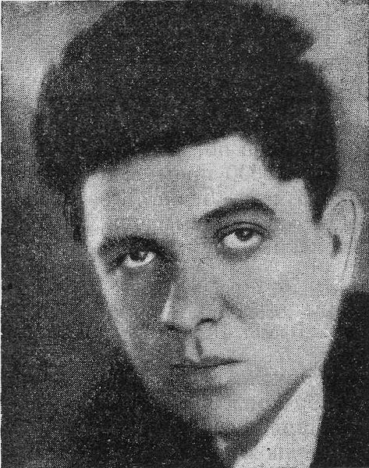

Ukrainian futurist poet and prose writer. Shkurupii was a close collaborator of Mykhail' SEMENKO, the founder of Ukrainian futurism, penning articles about Marinetti and the Art of Noises (i.e., music) in 1922. He debuted as a FUTURIST poet (“King of the Futurist Prairies”) that same year with a perplexing collection, *Psykhetozy* (Psychetosis), distinguished by eroticism, narcissism, neologisms, Dadaist elements and typographic experiments. The poems were ironic, anti-aesthetic, focused on urban themes, speed, and machines. Opposed to the SYMBOLIST cult of the Poet, Shkurupii’s later poems were topical, narrative and rhetorical in form; he blasted conservatism and philistinism, while showing enthusiasm for the new Soviet revolutionary order. In 1923 he also embraced prose. Determined to develop a mass readership, Shkurupii focused on plotting, defamiliarization, mystification and canonical popular genres like the detective story. His acute FORMALISM sometimes turned to self-conscious, meta-artistic practices, characterized by commentary on literary conventions that he set out to undermine in his writings. His most controversial novel was *Dveri v den'* [Gateway into Day, 1929], a mélange of literary and documentary forms for which Soviet literary critics condemned him. In 1930 he edited two issues of the futurist *Avanhard-Al'manakh proletars'kykh myttsiv Novoi generatsii* (Avant-Garde: Almanac of the Proletarian Artists of the New Generation). Shkurupii was executed during the Stalinist terror in 1937.

**References and Further Reading**:

Ilnytzkyj, Oleh S. (1997). *Ukrainian Futurism: A Historical and Critical Study*. Cambridge/MA: Harvard University Press; Ukrainian Research Institute.

Mudrak, Myroslava M. (1986). *The New Generation and Artistic Modernism in the Ukraine*. Ann Arbor: UMI Research Press.

**Major works**:

*Psykhetozy. Vitryna tretia* [Psychetosis. Display Window Three]. Kyiv: Panfuturysty, 1922.

*Baraban. Vitryna druha* [Drum. Display Window Three]. Kyiv: Panfuturysty, 1923.

*Peremozhets' drakona*. [Vanquisher of the Dragon] Kharkiv: DVU, 1925.

*Pryhody mashynista Khorna*. [The Adventures of Engineer Khorn] Kharkiv: Knyhospilka, 1925.

*Zharyny sliv. Vybrani poeziï*. [Embers of Words. Selected Poetry] Kharkiv: Knyhospilka, 1925.

*Dlia druziv poetiv suchasnykiv vichnosty*. [For my Poet-Friends, Contemporaries of Eternity] Kyiv: DVU, 1929.

*Dveri v den'*. [Gateway into Day] Kharkiv: Proletarii, 1929.

*Strashna myt'*. *Opovidannia*. [Terrible Moment. Short Stories] Kharkiv: Knyhospilka, 1929.

**Essays and Criticism**:

Shkurupii, Geo. “Manifest Marinetti i panfuturyzm.” *Semafor u Maibutnie. Aparat Panfuturystiv* 1 (May 1922): 8–10.

Shkurupii, Geo. “Muzyka shumiv (Musique bruitiste).” *Semafor u Maibutnie. Aparat Panfuturystiv* 1 (May 1922): 23.

**Oleh S. Ilnytzkyj, University of Alberta**

**Source url for image:**

<http://uk.wikipedia.org/wiki/Файл:Geo_Shkurupiy.jpg>